2nd October 2020

Dear Parents,

Next Friday 9th October we will celebrate GOAL Jersey Day in Scoil Naomh Treasa. GOAL Jersey Day sees communities across Ireland coming together and wearing their favourite jerseys to support GOAL's work with vulnerable communities. As this will be a non-uniform day, we are asking all pupils to donate €2 towards the charity, GOAL.

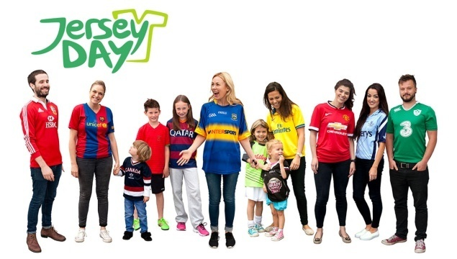
We are also teaming up with our local club Duleek/Bellewstown GFC for the #GAAbelong initiative on this day. We are encouraging everyone to wear their club/county jerseys if at all possible. However, other jerseys are permitted too and if your child does not own a jersey they are allowed to wear their own tracksuit on the day.

For more information on Goal Jersey Day: https://www.goalglobal.org/jersey-day/
Halloween Dress-Up
As is tradition in Scoil Naomh Treasa, children are encouraged to dress-up in their Halloween costumes on Friday 23rd October. This year, however, no props, accessories or face masks will be permitted.

Mid-Term Break
A reminder to all parents that school will be closed for mid-term break, from Monday 26th October to Friday 30th October.
Kind Regards,
Bernadette McGuinness

